NGO Gallery – Photo Titles (Batch 4)
Photos 61–64 · short English titles for the gallery page
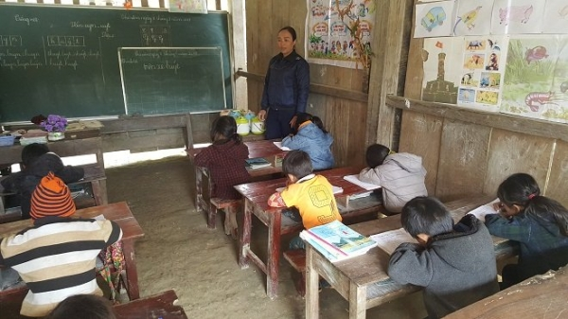  61 A Classroom of Dreams  xot-xa-canh-hoc-sinh-mien-nui-be-ti-teo-an-het-ca-au-com-trang-to-dung-ma-van-doi-con-cao-vi-thieu-chat-16-_1266.jpg | 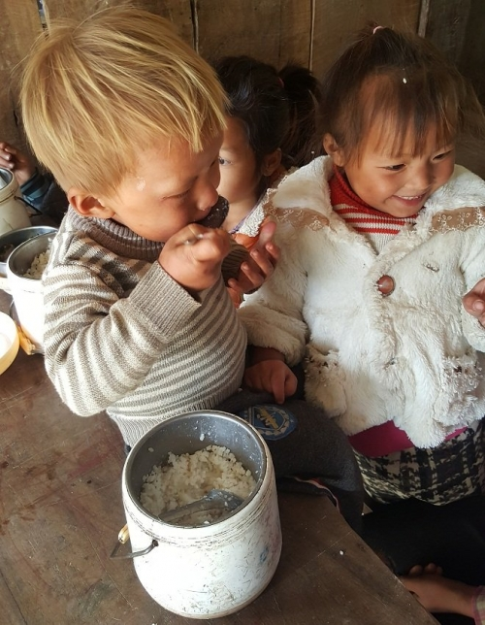  62 Plain Rice, Grateful Hearts  xot-xa-canh-hoc-sinh-mien-nui-be-ti-teo-an-het-ca-au-com-trang-to-dung-ma-van-doi-con-cao-vi-thieu-chat-11-_3024.jpg
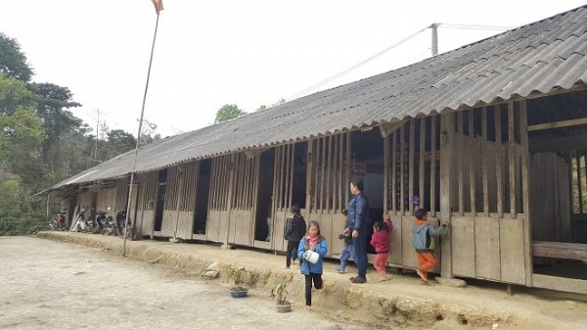  63 A Humble Schoolhouse  xot-xa-canh-hoc-sinh-mien-nui-be-ti-teo-an-het-ca-au-com-trang-to-dung-ma-van-doi-con-cao-vi-thieu-chat-12-_9824.jpg | 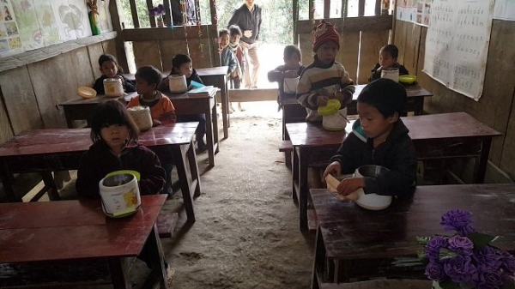  64 Waiting for Lunch  xot-xa-canh-hoc-sinh-mien-nui-be-ti-teo-an-het-ca-au-com-trang-to-dung-ma-van-doi-con-cao-vi-thieu-chat-13-_6262.jpg

